Oxford Junior Stars ICE HOCKEY CLUB

New Player Registration Pack
U9 – U20
2019-2020 season

Thank you for choosing to join Oxford Junior Stars Ice Hockey Club

In this pack you will find information that will help you complete the forms plus other useful information. If you need any help completing or understanding any part of this registration pack, please do not hesitate to contact our registrations secretary or any club official/team manager. All of the forms included in this pack are also available to download and print off from our website, www.oxfordjuniorstars.com. You will also find lots of other information on our website that we haven’t included in this pack and it’s worth taking a look.

In order for your child to be registered you will need to return the following:

- EIHA Master Registration Form
- Medical Consent Form
- General Agreement/Photography Consent Form
- Photocopy of your child’s Full Birth Certificate, showing place of birth and nationality of parents
or
- Photocopy of British Passport showing where the player was born
- Uniform Order Form
- Registration fee
- First month’s subs
- Uniform payment of £110

Please Note:
If the player is not British and/or has previously been registered to play ice hockey in a different country, some additional paperwork is required that is not included in this pack. If you think that this may apply to you, please contact our registrations secretary on the email address below who will be able to give you the extra forms.

Club Subscription Fees

Club subscription fees are payable monthly for 12 months, August to July, or you can choose to pay annually which attracts a 5% discount.

U9 (year of birth 2011 or later) £65 monthly or £741.00 annually
U11 (year of birth 2009 or 2010) £65 monthly or £741.00 annually
U13 (year of birth 2007 or 2008) £77 monthly or £877.80 annually
U15 (year of birth 2005 or 2006) £77 monthly or £877.80 annually
U18 (year of birth 2002, 2003 or 2004) £77 monthly or £877.80 annually

Monthly subscriptions must be paid on the 1st of each month.

A discount of £10.00 per month is given to a second player from the same immediate family.

English Ice Hockey Association fees (annual)

Annual registration with the English Ice Hockey Association (EIHA) is mandatory for all players, which covers official registration in to the EIHA league (allowing you to play in league matches) and insurance. The cost of this is set by the EIHA not the club.

Annual EIHA Registration Fees

U9 £30
U11 – U18 £60
U20 £85

Payments:
Payments for registration fees should be made by bacs and a standing order set up for the monthly subs.

Account Name: Oxford Junior Stars Ice Hockey Club
Sort Code: 20-65-18
Account No: 50257540

Training Times

Training is every Wednesday & every other Thursday from the second week in August to the end of June. There is a two-week shut down at Christmas.

Wednesday Training Times

Age Group | On Ice
Under 9 & 11 | 5pm to 6pm
Under 13 | 6pm to 7pm
Under 15 | 7:15pm to 8:30pm
Under 18 | 8:30pm to 9:45pm

Thursday Training Times

Every other week, teams get the chance to training from 6.20pm to 7.40pm, the ice is shared with our Learn to Play Programme

Age Group | On Ice
U9, U11 & U13 | Week 1
U15 & U18 | Week 2

Medical Consent Form

First Name |  | Surname
Date of Birth |  | Age
Address

Parent/Guardian Name for emergency contact |  | Parent/Guardian Phone No. for emergency contact
Parent/Guardian Name for emergency contact |  | Parent/Guardian Phone No. for emergency contact
Players Doctors Name |  | Doctors Phone No.
Pre-existing medical conditions or learning difficulties |  | Details of any known allergies

I authorise an official from Oxford Junior Stars Ice Hockey Club to agree to emergency treatment of an injury or illness of my child/myself if qualified medical personnel consider treatment necessary and perform the treatment. This authorisation is granted only if I cannot be reached and a reasonable effort has been made to do so. (This is a necessary precaution. If you do not accompany your child to training or games, treatment may be delayed without parental consent.)

My child and I are/am aware that participating in ice hockey is a potentially hazardous activity. I assume all risks associated with participation in this sport, including but not limited to falls, contact with other participants, effects of the weather, traffic and other reasonable risk conditions associated with the sport. All such risks to my child are known and understood by me.

I understand this consent form and agree to its conditions on behalf of my child/myself (if over 18).

Parent / Guardian Name / Player (if over 18) ________________________________________

Parent / Guardian Signature / Player (if over 18) ____________________________________

Date _________________________________

GENERAL AGREEMENT & PHOTOGRAPHY CONSENT FORM

GENERAL AGREEMENT:

On signing this agreement, you are confirming you have read, fully understood and agree to abide by the rules set out in the polices listed below.

Oxford Junior Stars Ice Hockey Club Rules
Player Code of Conduct
Parent/Guardian Code of Conduct
Child Protection Policy Statement
Equality and Diversity Policy
Changing Room Policy
Mobile Phone Policy

These documents are all available at www.oxfordjuniorstars.com/policies

PHOTOGRAPHY CONSENT:

From time to time we have photographers asking to take photos of, or film our junior teams during training and whilst they are playing games. We would like parent’s/guardians permission to use pictures of your child to help promote ice hockey and our club.

I give permission for photos of my child/myself (if over 18) to be used for publicity purposes to help to promote Oxford Junior Stars Ice Hockey Club and the game of ice hockey in any media format deemed suitable and appropriate by the club committee. I also agree for team photos that include my child/myself (if over 18) to be placed on the club notice board, websites and/or walls at the rink to help promote ice hockey/Oxford Junior Stars Ice Hockey Club at the rink.

Player First Name |  | Surname
Date of Birth |  | Age
Address

Parent / Guardian Name / Player (if over 18) ______________________________________

Parent / Guardian Signature / Player (if over 18) __________________________________

Date __________________________________

THE ENGLISH ICE HOCKEY ASSOCIATION LTD

MASTER REGISTRATION FORM 2019/2020

PLAYER’S UNDER THE AGE OF 18 YEARS

……………………………………………………………………………………………………………………………………………………………………………………

ALL BOXES MUST BE FILLED IN USING BLACK INK – PLEASE USE BLOCK CAPITALS

NATIONALITY: IMPORTANT:

Please indicate if dual national:

COUNTRY OF BIRTH: IMPORTANT

LAST CLUB: IMPORTANT

COUNTRY LAST PLAYED IN – IMPORTANT

……………………………………………………………………………………………………………………………………………………………………………

Family Name:

Forename(s):

Date of birth: Sex:

Address:

Tel No: Email:

I hereby consent for my child to be registered as a player with the English Ice Hockey Association Ltd and this consent applies to any future club player may transfers to. I undertake that he/she will observe the Rules, Regulations and Bylaws of the EIHA, IHUK and the IIHF and affiliated bodies and to observe the codes of conduct with whichever club he/she may be registered with.
I understand that the information on this form will be held on a computer and is subject to the Data Protection Act. Information about my child may be added to a list so that my child can be contacted by the EIHA.

Signature of player’s parent/guardian …………………………………………………………………. Date: ……………………………………………

Signature of club official …………………………………………………………………………………………CLUB: …………………………………..
FULL NAME OF CLUB REQUIRED (No initials)

TEAM SHIRT ORDER FORM

1. Before ordering, please email ojsihcjerseyorder@gmail.com to choose an available player number.

2. Once you have your number confirmed, please complete this form and email it to the same address as above.

3. The total cost for the uniform is £110. Please make payment to the Oxford Junior Stars bank account and email treasurer.ojsihc@gmail.com to confirm your payment has been made. Note: We cannot proceed with your order until payment has been received.

Player Name |  |  | Age Group
Jersey Size | Home- White |  | Away – Blue
Sock Size | Home – White |  | Away – Blue
Short Cover Size | Blue
Name to be  Printed |  |  | Number to be printed

Sizing Guides
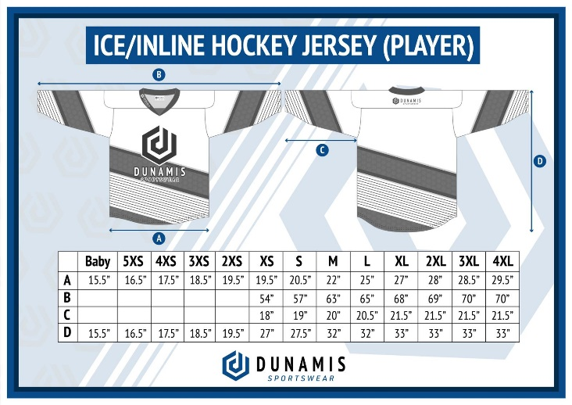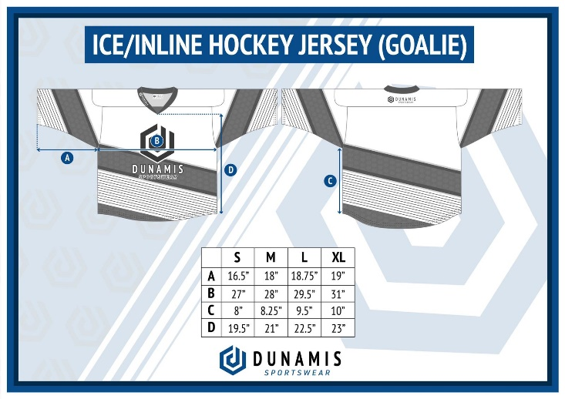
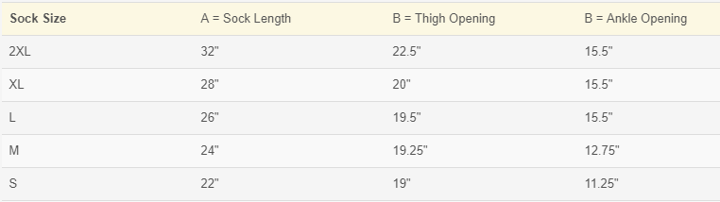
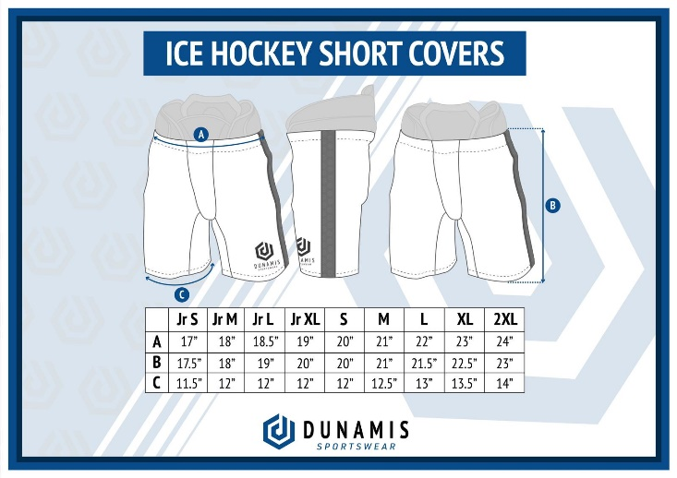

Goalies:
For a Net Minder, please write clearly ‘Net Minder’ or ‘Goalie’ then the size. Use your current CCM Jersey size as a guide. Goalie sizes are the same width, just with two extra side panels.

Sizing Queries:
If you are unsure of your size, please ask your coach to help you try on one of the clubs CCM Jerseys. Rose Evlat can also assist you with sizing. Please contact her via email: OJSIHCjerseyorder@gmail.com
CHECKLIST

Before you return your completed registration pack please complete the following checklist to ensure you have everything required to process your registration:

 | FORM | INCLUDED
 | Master Registration Form
 | Medical Consent Form
 | General Consent & Photography Form
 | Full Birth Certificate
 | Passport (Only required if unable to present Full Birth Certificate)
 | Team Uniform Order Form
 | Registration Fee
 | First month’s membership fee
 | Team Uniform Payment

